

**ASSIGNMENT-1**

**BY**

**TAMMANA ASHISH**

**18STUCHH010302**

**BTECH 4TH YEAR,**

**ICFAI UNIVERSITY**

**Company website:** http://www.swastikpharma.in/

The Required changes to be made to increase the customer traction are:

MODIFICATIONS ON OUR WEBSITE

**INTRODUCTION:**

Sales of pharmacy products are increasing both in developed and developing countries, and COVID-19 has brought a new wave of online consumer demand for over-the-counter (not-prescription) medications, as well as wellness products.

Digital advertising for pharmacy ecommerce websites is heavily regulated in most countries, so pharmacies' digital properties must make a great first impression on users to convert and keep them.

Search is especially critical on an ecommerce pharmacy platform where shoppers know what they want. When search is designed and optimized properly on a pharmacy site, it can transform conversion rates.

**PHARMACY WEBSITES:**

As there is a drastic improvement in our technology. Pharmaceutical companies also have started selling their products in online through their websites. As these websites have gained attraction across customers in this pandemic period people are mainly focused on purchasing products from these online websites.

It is significant that pharmacy companies are making their websites convenient to people. Companies are also trying to reach customers with social media apps through their websites. Interaction with the people also plays as a major attraction such as live chat etc.

**WHAT CHANGES CAN BE MADE/INTRODUCED:**

* CHAT FEATURE
* SEARCH BAR
* ONLINE PURCHASE WITH TRACKING
* ANIMATION
* FRIENDLY USER INTERFACE
* QUALITY CERTIFICATES
* HOME PAGE AND ABOUT US
* CUSTOMER’S FEEDBACK

🡪**CHAT FEATURE:**

Only 9% of businesses offer live chat on their website, and more than 30% of customers expect live chat while only 30% provide it. Live chat is also a good sales tool; it can increase conversions by 45%.

Customers prefer live chat over email or phone due to its 1-on-1 nature, convenience, and real-time nature. Live chat empowers businesses to offer real-time support as customers ask questions in a chat application.



There are incalculable advantages to having the option to support a client's necessities straight away.

For instance, rather than sitting tight for information from a site structure to be populated in a CRM framework, you have the chance to visit with a client when they're on your site, during a period that is ideal for them.

In this day and age, clients would prefer not to pause. They likewise don't have any desire to telephone organizations and spending quite a while on hold.

Clients need to converse with a specialist who can respond to their particular inquiries, straight away.

🡪 **SEARCH BAR:**

For the majority of website owners, one of the most basic concerns is the use of search functions for the purpose of enhanced user experience. The websites tend to grow over time, adding more and more content for driving customers.

However, these new content categories can prove to be useless, if they are not properly organized. In this case, an efficient search portal is not only helpful but crucial for basic site navigation.



A search function is a design strategy that can offer users an easy way to find content. Users can locate their search query by simply searching for specific words and phrases. Site navigation can be made quicker and more efficient.

**🡪ONLINE PURCHASE:**

Online shopping allows people to purchase products from and companies they can't locate or are not readily available in their locality. In this way, the company offers its customers a very convenient experience, because they can store items into a personal shopping bag, and purchase them later. For people with a valid credit card or a bank account online, this is a convenient experience.

Selling direct online increases our website reach. Selling across towns, states is possible online shopping can reduce phone calls between buyers and retailers, because details such as availability, specifications, hours of operation, and price can be found easily on company and product pages.

**🡪ANIMATION:**

Some animation can be given in the home-page and poster can also be given such as a slogan or a tagline which can attract viewers.

Minimal animation of the product should be given so that it can create an attraction to the people who visits our website. It can be a creative idea for boosting our website.

**🡪FRIENDLY AND USER INTERFACE:**

HOMEPAGE:

Contact information -mail id can also be mentioned to the right corner with social media links and contact number can be given below them

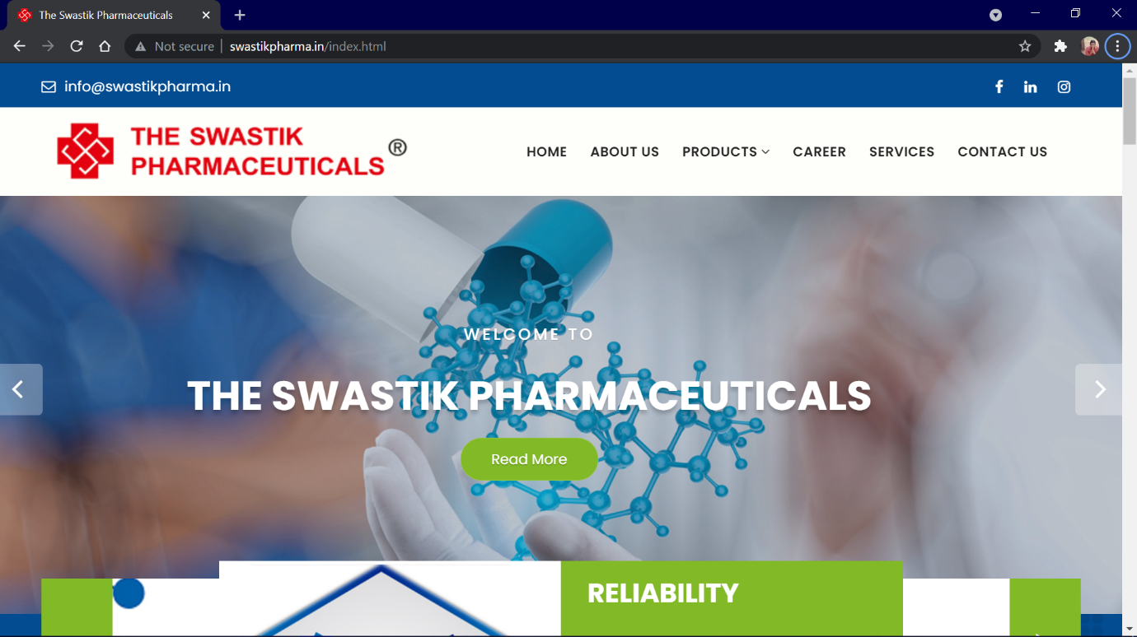

So that is can be easy for viewers to contact us through the given links.

CHANGE OF THE LOGO:

Logo can be more appealing if we give a slogan or a tagline below the company’s name.

ABOUT US:

Information about the company such as Founder, Director, and manufacturing house can be mentioned. Information such as when the company was established must be given.

**🡪QUALITY CERTIFICATES:**

Quality certificates of the products are shown it would create an impact on viewers. And it can be useful for the purchasers

We can also give advantages of buying our product by comparing with other products available in the market.

🡪**CUSTOMER’S FEEDBACK**

Our customers' feedback is vital for guiding in our decision-making and helping us to make innovations and changes to our product or service. It's also essential for measuring customer satisfaction among our current customers.

Understanding how customers feel about our product, support, and company is vital.